**Topics: Normal distribution, Functions of Random Variables**

1. The time required for servicing transmissions is normally distributed with *μ* = 45 minutes and *σ* = 8 minutes. The service manager plans to have work begin on the transmission of a customer’s car 10 minutes after the car is dropped off and the customer is told that the car will be ready within 1 hour from drop-off. What is the probability that the service manager cannot meet his commitment?
2. 0.3875
3. **0.2676**
4. 0.5
5. 0.6987

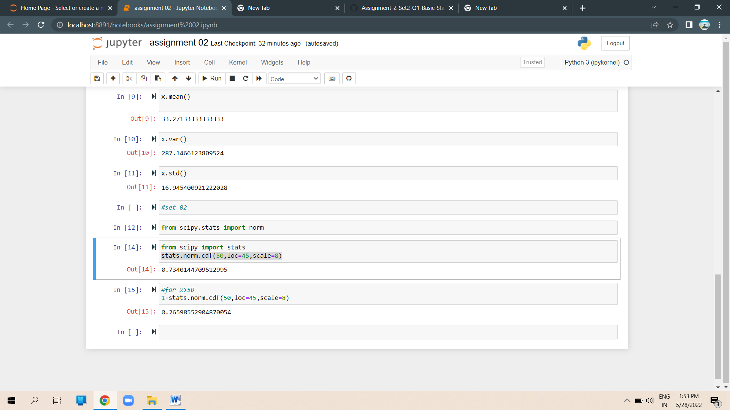

1. The current age (in years) of 400 clerical employees at an insurance claims processing center is normally distributed with mean *μ* = 38 and Standard deviation *σ* =6. For each statement below, please specify True/False. If false, briefly explain why.
2. More employees at the processing center are older than 44 than between 38 and 44

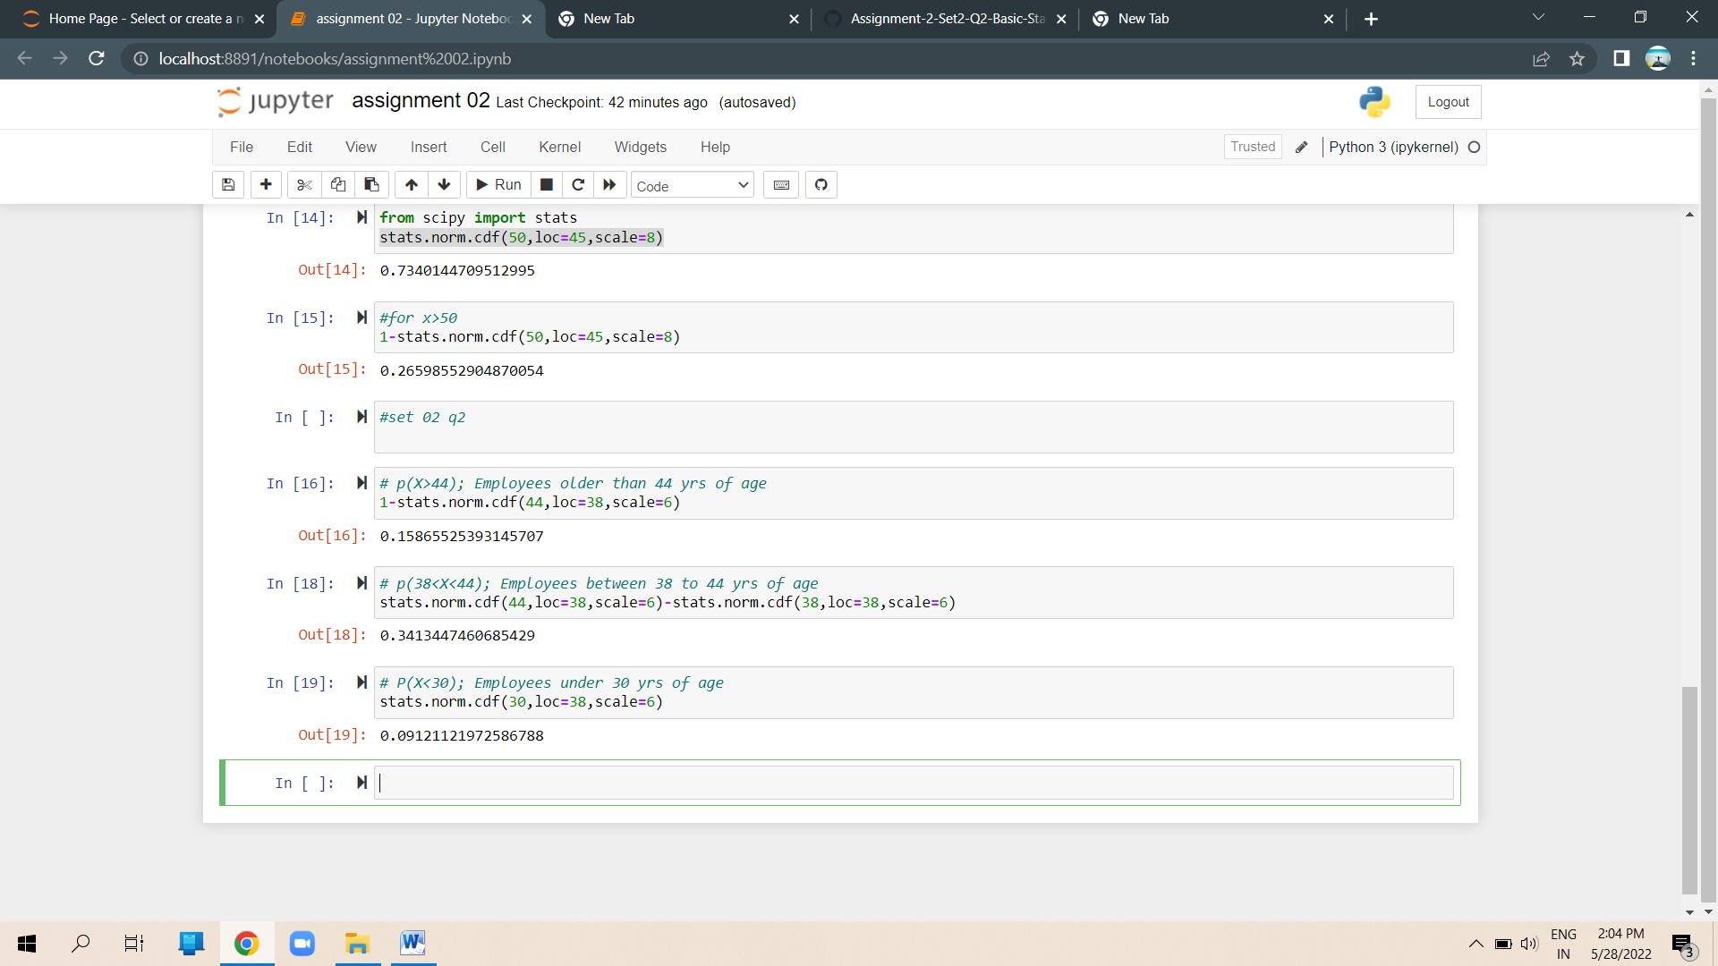

1. A training program for employees under the age of 30 at the center would be expected to attract about 36 employees.



**Ans =True**

1. If *X1* ~ *N*(μ, σ2) and *X*2 ~ *N*(μ, σ2) are *iid* normal random variables, then what is the difference between 2 *X*1 and *X*1 + *X*2? Discuss both their distributions and parameters.

**Ans=** 2 is simply a larger scale version of the random variable X 1. If is normally distributed then 2X1 is also normally distributed. X 1 and X 2 are normal distributed, the associated sums and random samples are exactly (and not just approximately) normal, with the appropriate parameters.

1. Let X ~ N(100, 202). Find two values, *a* and *b*, symmetric about the mean, such that the probability of the random variable taking a value between them is 0.99.
2. 90.5, 105.9
3. 80.2, 119.8
4. 22, 78
5. **48.5, 151.5**
6. 90.1, 109.9

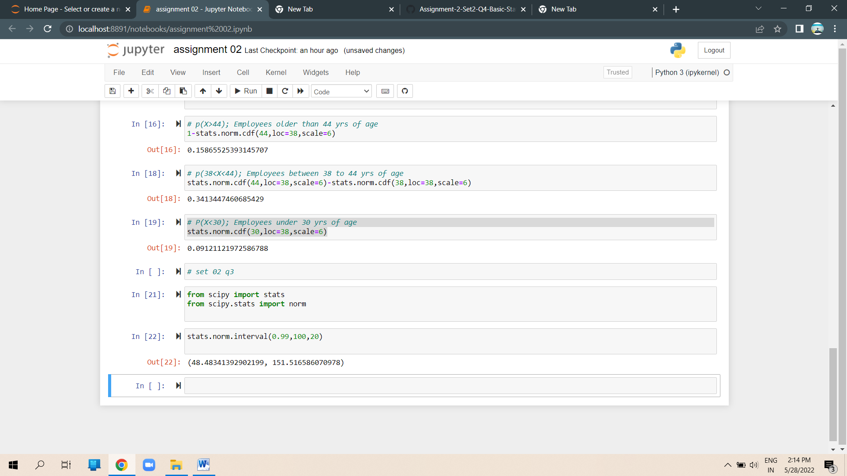

1. Consider a company that has two different divisions. The annual profits from the two divisions are independent and have distributions Profit1 ~ N(5, 32) and Profit2 ~ N(7, 42) respectively. Both the profits are in $ Million. Answer the following questions about the total profit of the company in Rupees. Assume that $1 = Rs. 45
2. Specify a Rupee range (centered on the mean) such that it contains 95% probability for the annual profit of the company.
3. Specify the 5th percentile of profit (in Rupees) for the company
4. Which of the two divisions has a larger probability of making a loss in a given

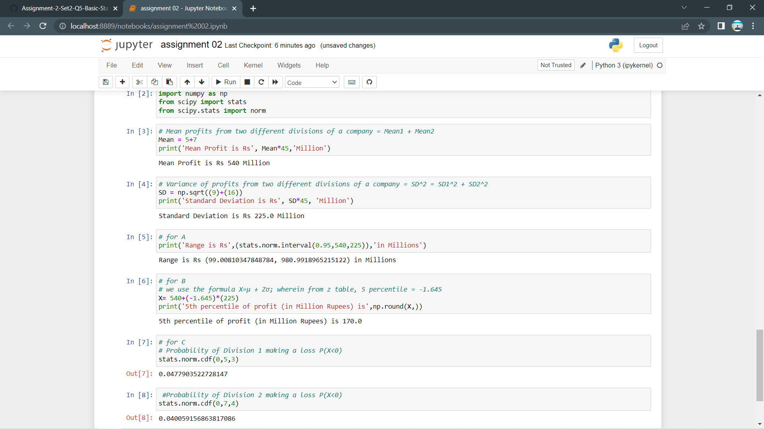

A) **Range**containing 95% **probability** for **profit**of **company**is

(Rs. 99M, Rs. 1026M).

B): Rs. 170.1 Million.

C): First **division**of the **company**has larger **probability**of **making**a **loss**.

Given that:

$1 = Rs. 45



Thus,

**Company's profit**:



A):

95% of the **probability** **lies**between 1.96 **standard deviations**of the **mean**.

Thus **range**is:

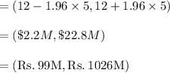

B): **Fifth percentile**is calculated as:



From p **values**of z **score** **table**, we get:



Thus at $3.78M **dollars**, or Rs. 170.1M **amount**, 5th **percentile**of **profit** **lies**.

Or 5th **percentile**of **profit**is Rs. 170.1 Million.

C): Loss is when profit < 0 The first **division** of **company**, thus have **larger probability**of making a loss in a given year.